**MATHEMATICS**

**NUMBER SYSTEM**



Arranged By :

Dicha Zelianivan Arkana 2241720002 / 1I / 05

Shofa Yassmin Fauziah 2241720108 / 1I / 23

**INFORMATION TECHNOLOGY**

**D-IV INFORMATICS ENGINEERING**

**MALANG STATE POLYTHECNIC**

**2022**

**Definition**

**Number System** is a way of representing number using different basis. The most commonly used number system is **decimal** which has the base of 10, meaning that the number consists of 10 different numbers, namely 0, 1, 2, 3, 4, 5, 6, 7, 8, 9. Different number systems are used for different purposes. For example, decimals are used in our daily life. Binary, octal, and hexadecimal are used for computers.

**Examples**

* Example 1 - Converting from Binary to Hexadecimal

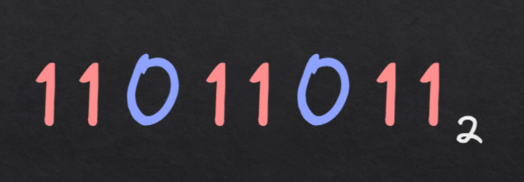

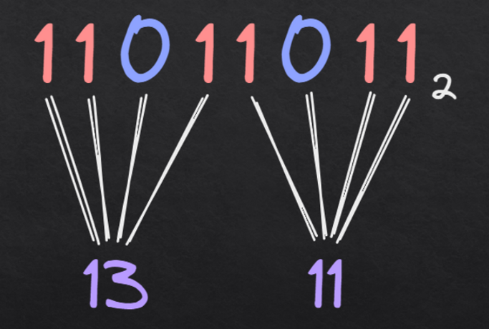

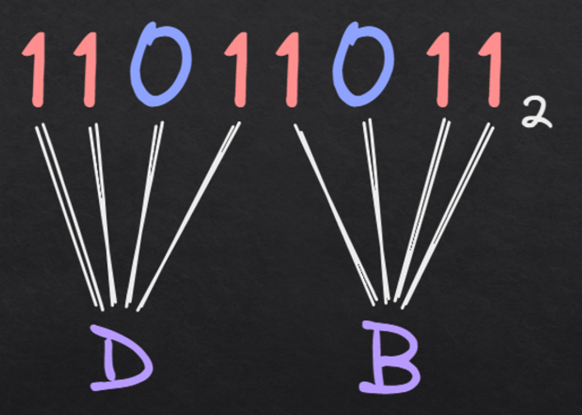

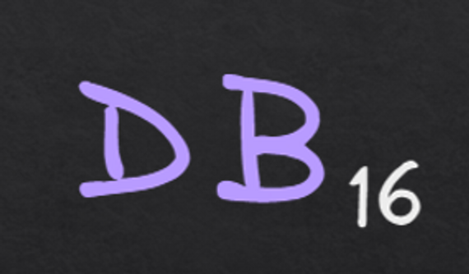

* Example 2 - Converting from Binary to Octal

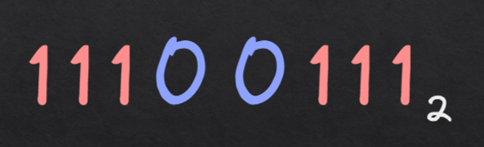

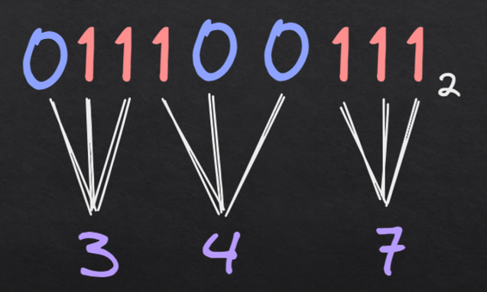

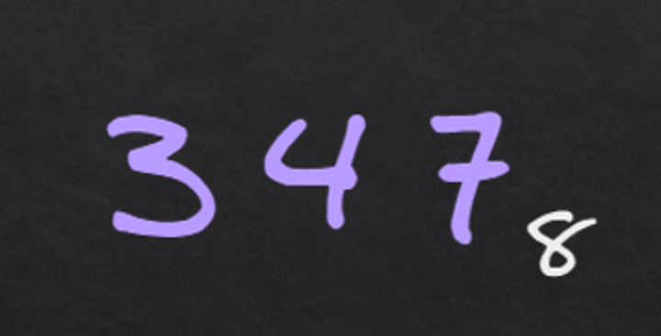

* Example 3 - Converting from Binary to Base-4

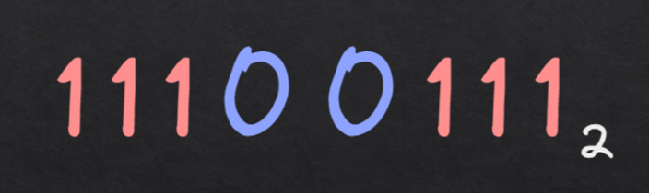

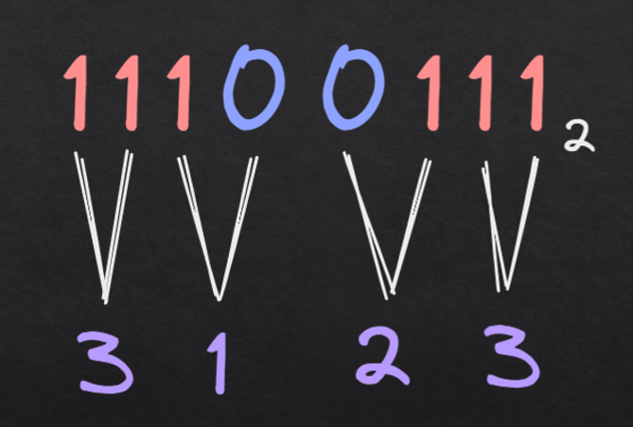

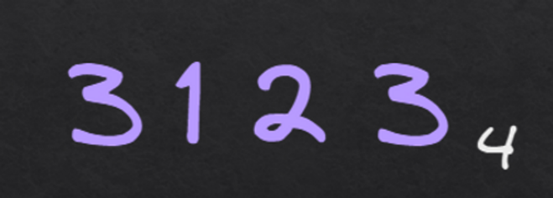

* Example 4 - Converting from Base-4 to Octal

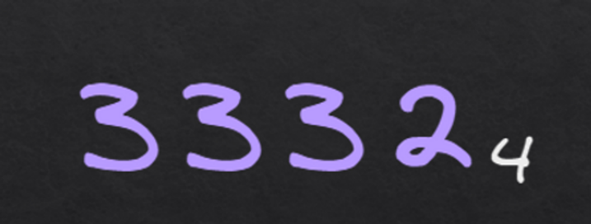

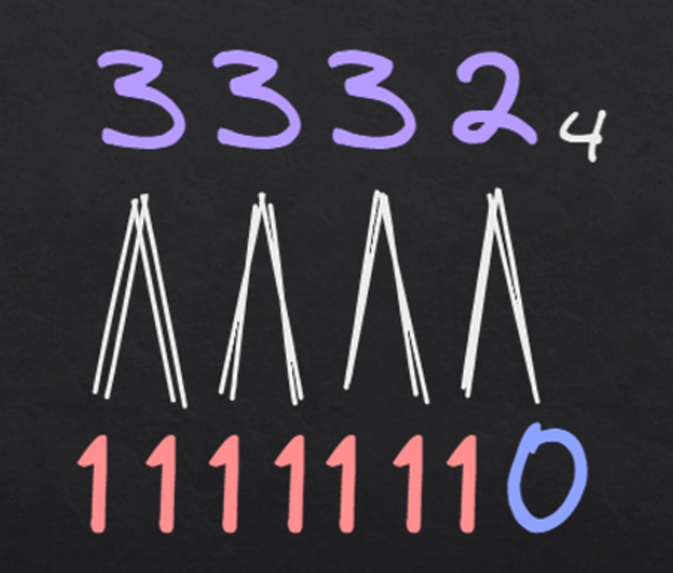

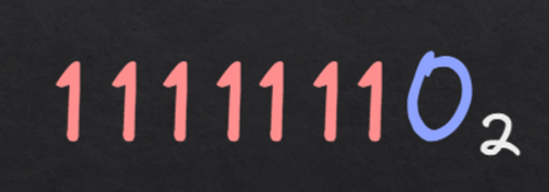

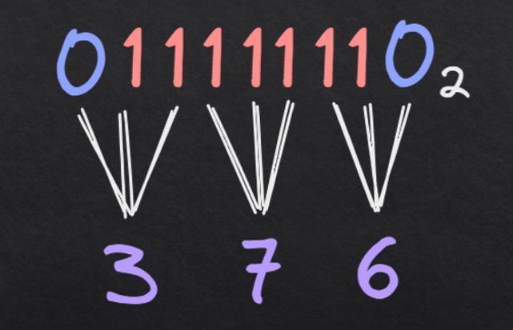

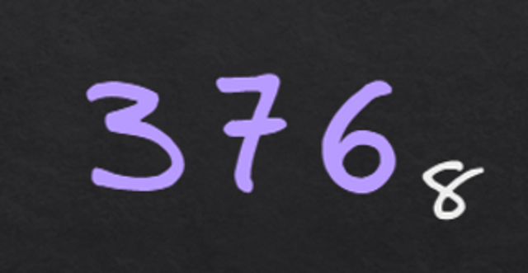

* Example 5 - Converting from Base-4 to Hexadecimal

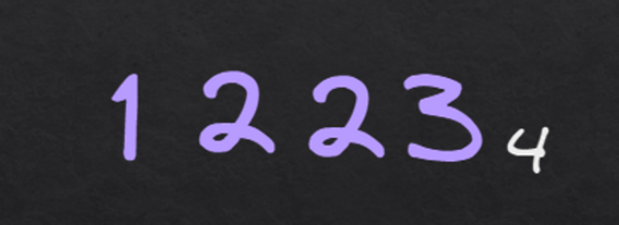

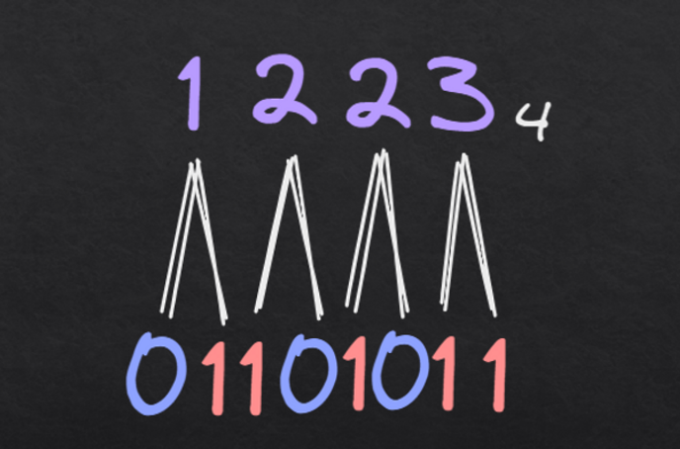

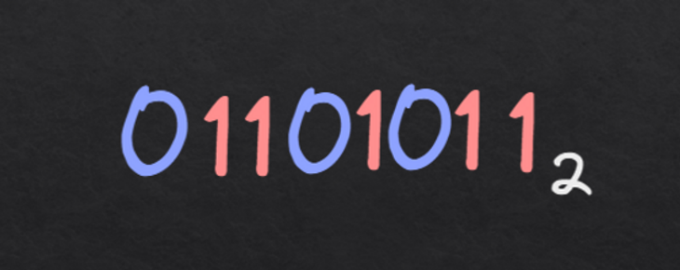

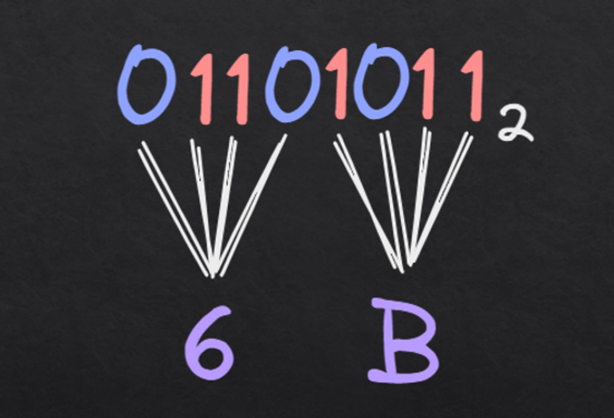

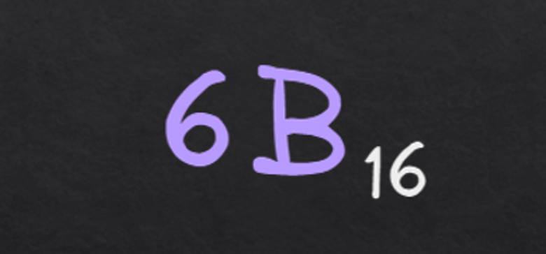

**Problems**

1. 11000110 2 = ... 16
2. 11100101 2 = ... 8
3. 10010110 2 = ... 4
4. 312 4 = ... 8
5. 232 4 = ... 16